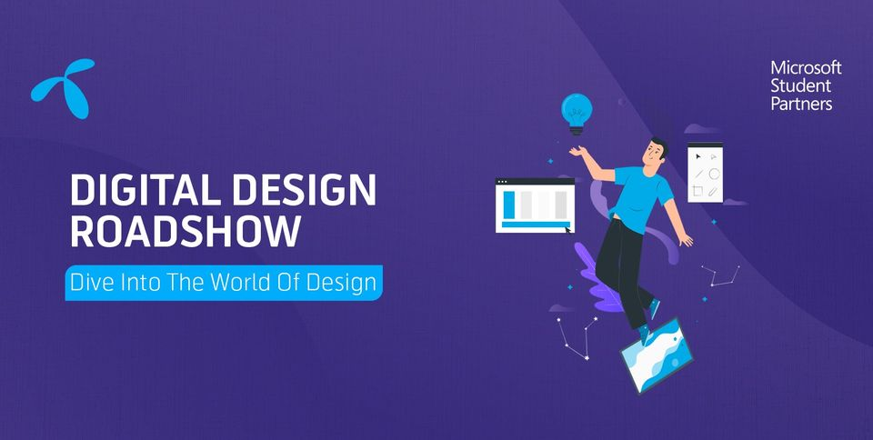

Powered by Microsoft Learn Student Ambassador Program and Telenor.

**Views about UI/UX before roadshow**

As the word UX/UI sounds straight out of some sci-fi world, so never actually looked into this field before this amazing roadshow.

It not only familiarized me with this lively and interesting industry but also developed in me an intuitive sense of digital design. The key factor I learnt was that designing is different from ‘decoration’, it is a proper study and the more we dive into it, more we realize that it’s not as simple as it looks.

Digital design is a thorough and multi staged process. The more effort, dedication and time we invest in the initial phases, better and beautiful the results come out in later stages.

///////////////////////////////////////////////////////////////////

**Project**: Meal Plan App

**Resources**: Figma, Coolers, and Real Persons (case study)

///////////////////////////////////////////////////////////////////////////

**Introduction**:

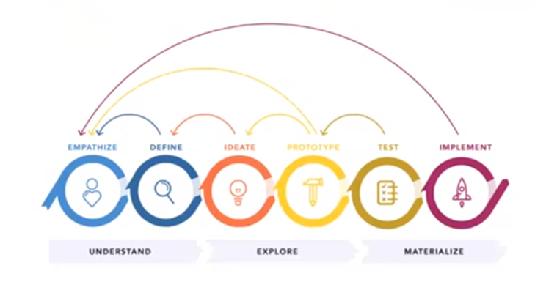We were required to complete a capstone project i.e. complete design process of a meal plan app. The approach I used was:

1. To get details about meal plans, diet habits, different food orientation for different regions through internet platforms.
2. After gathering detailed information, personally interviewed 2 very diet conscious persons in an informal fashion that directly connected me to the people I would be providing solution to.
3. Pinpointed that there is no ‘one solution for all’ in this problem. I have to be specific about my target audience and make their life better.
4. With this knowledge, refined path and clear vision, now was the time to move onto softwares to craft the solution. Tool used was figma and once again I thank the entire MLSA and Telenor team for introducing me to this amazing tool.
5. After completing the prototype, now had to test my proposed solution. Though the project doesn’t require testing phase, I brought my figma design to my family members anyway and hence, it was rigorously tested, along with brutally honest feedback :D

1. After improvements, feedback and then improvements… I was finally able to feel confident about my design. Added it to my portfolio, linkedIn and also published this case study in order to document my first ever project on UI/UX design.

///////////////////////////////////////////////////////////////////

**Case Study**

///////////////////////////////////////////////////////////////////

Following case study discusses, in detail, the entire approach I went through in my design process for meal plan app.

**Phase 1**: Empathy

The most underrated yet most important step of designing is the research phase, also known as empathy.

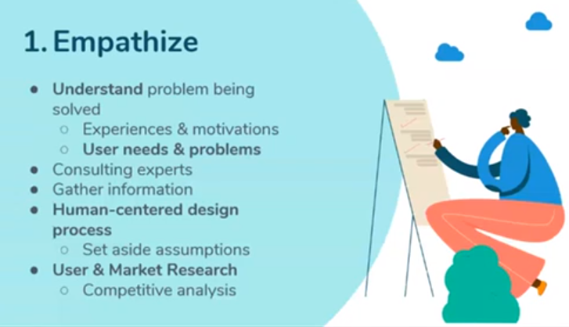It is **crucial** to connect with the emotions, sentiments and the need of people or society for which we are to provide a solution. I have a person or two in my family, very close to me, with this dilemma so connected with the problem statement straight away. I had personally expereinced the seriousness of the issue, how it affects the lives of people that are concious about the diet. So, got the empathy and feel for the project and started to research even more. Which prospects have already been dealt with, and what can I add or choose from them in order to address my case area and poblem domain.

Found out that there are many excellent meal plan apps and solutions out in the market for me to take guidance from and craft my own solution for my specific target audience.

**Phase 2**: Define

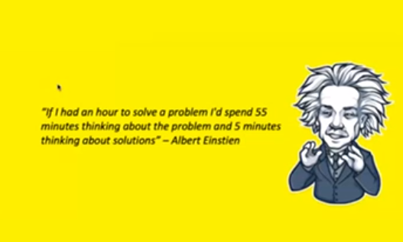The mistake people make is that as soon as they are given task, blindly just open up soft tools, produce a solution, and only then move out to find an audience. It should be the other way around as our brother Einstein suggests 🡪

The problem statement in this project was to design a meal/diet planning android app. I worked on its definition by asking questions to myself like what is the specific target I want to achieve, which type of people do I want to address and so on.

Finally, after a rigorous Q/A session with myself, concluded that I was to target the people that took this very seriously and are mostly concerned about their body posture i.e. how they look.

This completed my define phase and I was clear to move forward with my process.

**Phase 3**: Ideate

I short listed the audience that were way too serious about their physique, body posture, and diet intake as my target because these were the people that appreciated and needed guidance or suggestions the most, and would be most readily available.

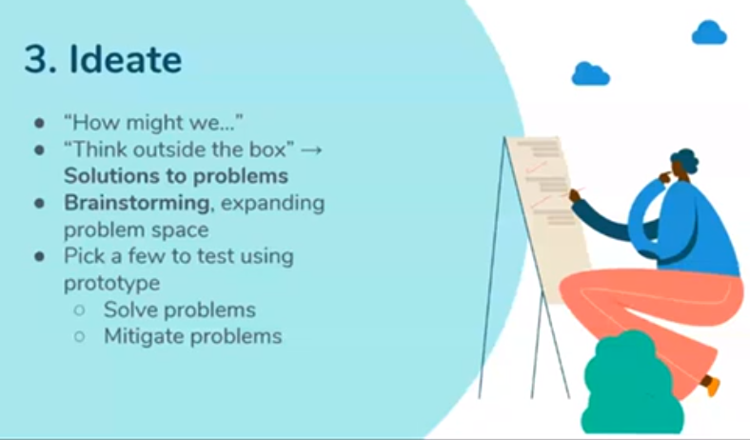Now in this phase the question was ‘how might we…’

So, again took the notepad and backed myself up for another Q/A session. This time thinking about the **solutions** for the very **first** time in my design process. Some important questions that I discussed with myself were as follows:

* How might we make the app easy to use for everyone?
* What color pallets should I use in order to stir emotions in audience?
* How might we make the app efficient and compatible with the daily routine of the target audience?

And many more. Finding the solution was time consuming and required a lot of iterations through all the previous phases over and over again until at last all the mayhem converged into a crystal clear direction to be followed. My proposed solution was

“*An app that is easy to navigate through from login to menus in order to be equally useable by laymen and the literate ones. It would have color pallets that spark hunger and freshen up the mood. And lastly, it would have plans that considered the daily routine of people of our society rather than having a solution based on western compatible standards*”

With this clarity in approach and all the intensive paperwork done. It was time to gear up the task and create a prototype for the app using software tools.

**Phase 4**: Prototype

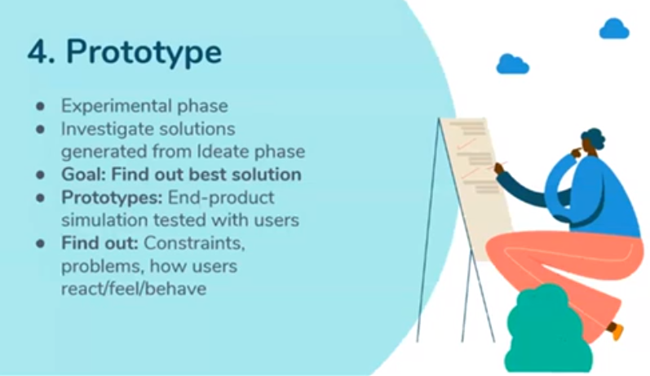In this phase it is recommend almost always to first sketch out our ideas onto paper, which is what I did.

After a number of trials and errors, I came up with a design view that I was satisfied with and now was the software part. The tool I used was figma, for color pallet I used coolers and the rest was all up to my imagination, visualization and creativity.

Following is the JPEG file of my meal plan app:

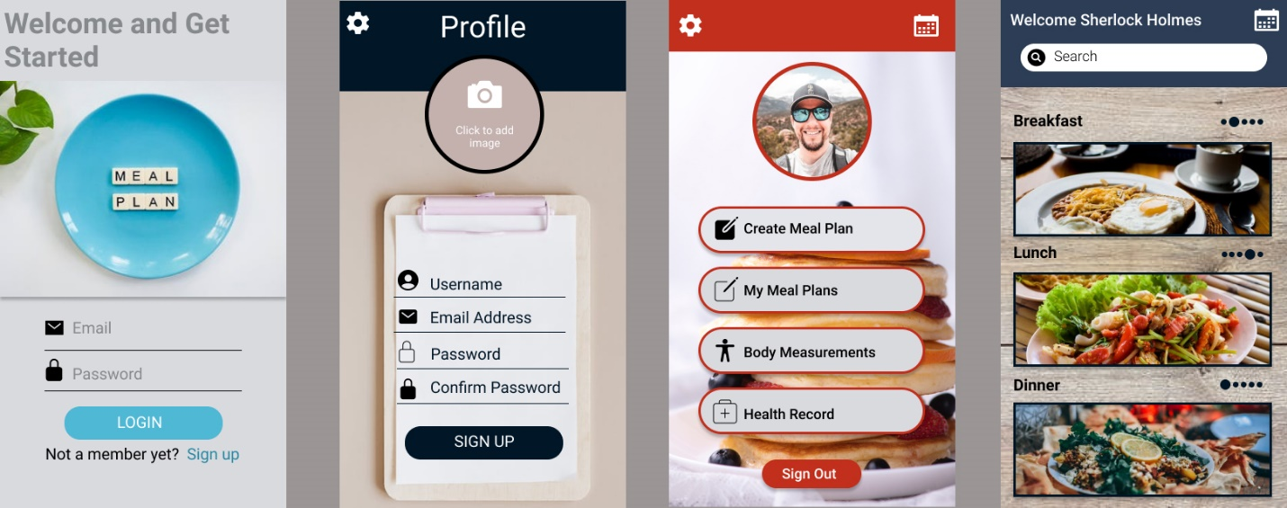

This was my first ever design so obviously, there would be many room for improvements in each layout.

Figma link:

https://www.figma.com/file/Kh65kwmgjtuoErGqyZnZEi/Meal-Planner?node-id=0%3A1

**Phase** 5: Test

The testing phase was done by my family members and friends which played around with the prototype.

**Phase** 6: Implement

InshaAllah, will continue to improve my UI/UX design skills and build my portfolio. When given chance, surely will implement my designs in real world scenarios.

///////////////////////////////////////////////////////////////////////////

**Acknowledgements:**

A huge shout out to the ***Microsoft Learn Student Ambassador*** team and ***Telenor*** to organize such an informative and amazing roadshow. Learned a lot and thank you so much to the mentors, instructors and organizers.

Author: **Muhammad Umair Shahid**

Email: **umairshahid8796@gmail.com**